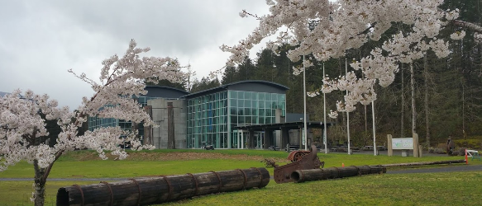

2022
Issue 3

In this issue >>>
Current topics >>>

Please remember that all ticket sales and auction proceeds will help CGICM keep our local history preserved to share with generations to come. Everyone at CGICM thanks you for your continued support of our incredible heritage, as well as your patience during the Covid-19 Pandemic.

Events like the auction are made possible in part by the City of Stevenson and Skamania County Lodging Taxes… Thank you and we look forward to spending this “Totally Rad” 80’s night with you all!


It’s time to step “Back to the 80’s” with CGICM! So pull out the costumes, hairspray, or those old boxes of clothes from your high school days, and join us for an evening of fun memories for all! Remember: Prizes for best Costume, Hair, Makeup, and all over 80’s persona come to life!

CGICM would like to invite you and your family/friends to join us on Saturday, July 16th 2022 for our 29th “IN PERSON” Silent Auction and Dinner from 4-8 PM. The evening will feature a buffet dinner by Skamania Lodge, as well as a cash only Bar. Tickets are $50 a person/ $400 a table, and can be purchased in advance at the museum, or by calling 509-427-8211.

Some items that will be available for auction include:
- Season Tickets: Vancouver Symphany
- Mariner’s Family Tickets
- Hotel and Getaway Packages
- Wild Waves
- 4 Tickets to Seafair in Seattle
- Local Restaurant Gift Cards
And so much more- don’t miss out on your chance to be an auction winner, as well as a support the continued work at CGICM.

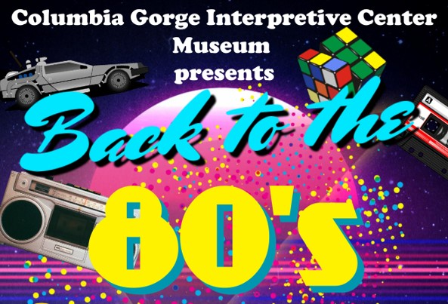

AUCTION TICKETS AVAILABLE FOR PURCHASE AT:
Columbia Gorge Interpretive Center,
Skamania County Chamber of Commerce,
and Riverview Bank in Stevenson!
LAST COMPLIMENTARY NEWSLETTER…RENEW YOUR CGICM MEMBERSHIP TODAY!
Issue 3 of “Explorations” is the last complimentary newsletter being mailed out to past members. Don’t miss out on upcoming events and fun historical pieces about our beautiful Skamania County! If you have not already renewed your CGICM Membership, or if you are not sure if your membership expired, please call 509-427-8211!

Remember being a part of the CGICM Family includes great benefits, from FREE Entry into the Interpretive Center to FREE entry into over 1,000 museums across the USA with the NARM membership levels, Gift Shop Discounts, and Discounted Rental of our beautiful facilities. All Memberships and Donations are also tax deductible, as your membership supports an incredible 501c(3).

Renew today, and you will be sure to receive your Oct 2022 Isssue of Explorations, our “Member’s Only Newsletter,” dedicated to the preservation of local history!
Auction Dinner Returns in Person
Tribute to Ed Callahan
Past Comes Alive-27th Anniversary
Chasing the Light-Brian Chambers
Skamania County Historical Society and Columbia Gorge Interpretive Center
29th Annual Silent Auction and Dinner Returns!
Explorations

VISITOR’S CORNER
“Loved it, especially the geology! Great Work!
-Sunlakes, Arizona

“Love the quilts and the Indian Exhibits!
Thank you!”
-Clarksville, Tennessee
April-June 2022 Visitor Count: 6036

Message from the Director- “Planned Giving”
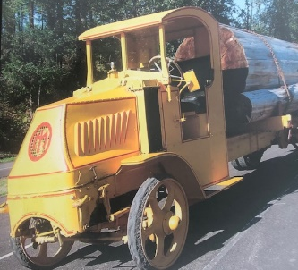
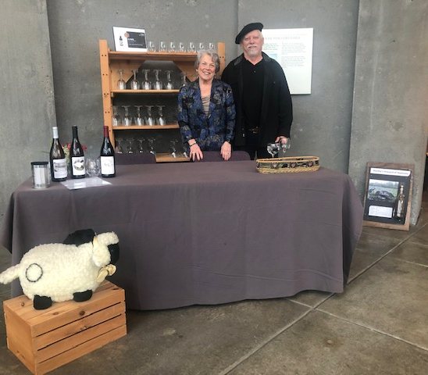
These are just a few great ways to help support the preservation of our local history, as well as the continued education of our past, present, and geology to visitors from all over the world.
If you would like more information, feel free to give me a call, as well as speak to your personal financial advisor as to the benefits of Planned Giving. Thank you for considering CGICM as you plan for the future!
- Planned Giving also referred to as “Estate planning or Legacy giving” can protect you and your family during distribution of assets, with the goal to help minimize unnecessary fees and taxes.
- QCD & RMD’s take a qualified charitable distribution (QCD). If you’re at least 70½, you can make a qualified charitable distribution (QCD), which involves moving money directly from your traditional IRA to a qualified charity. By taking a QCD, you can satisfy some, or possibly all, of your (Required minimum distributions (RMDs) from retirement accounts) for the year, and you can exclude them from your taxable income, which may reduce your income taxes. (The maximum amount of QCDs that can be excluded is $100,000 per taxpayer per year.)
Thank You, Rob Peterson-Executive Director

Because of a conversation with an anonymous donor regarding their recent and generous donation of $10,000 dollars, from the sale of some personal property, I was very pleased and encouraged to learn that this was a “plan” that the family had in place for a while. CGICM would like to extend a huge “Thank you” to them for keeping us in their thoughts and planning, as donations such as these helps preserve our local history for generations to come. A few days later, I was having a conversation with the museum’s tax advisor, and she mentioned that there are a few great ways that ones can give, and it is incredibly beneficial to both parties (listed below).

Mark Your Calendar >>>

July 6th, 2022
Chamber After Hours at CGICM, 5-7pm
JOIN US for light refreshments!

July 16th, 2022
29th Silent Auction/Dinner 4-8 pm

September 3rd, 2022
25th Show & Shine Fundraiser, 9-4 pm

Don’t Forget every first Saturday is FREE for the local community- be a tourist in your own hometown!

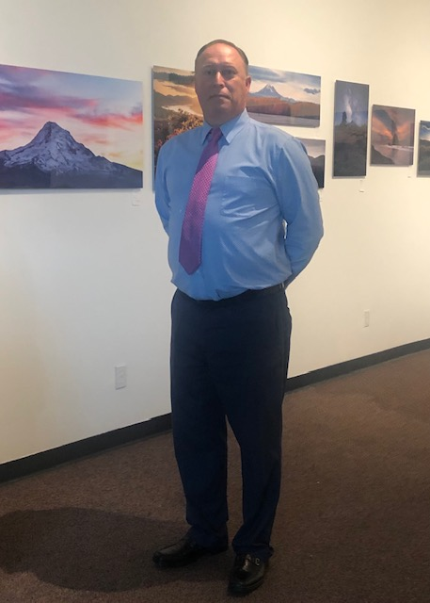
Planned Giving and Donations
From the early planning stages of the Interpretive Center in 1979 to its grand opening May 17th, 1995. Ed was there every step of the way! “Ed Callahan is on top of my list of influential people to the Center.” said Sharon Tiffany, the first Executive Director of CGIC. Ed was not only instrumental in acquiring Local, County and State Financial Support, but donated a substantial amount of personal funds, as well as the 1921 Mack Log Truck on display. Ed Callahan was instrumental in bringing Jean Jacques Andre, world renowned exhibit designer, on board to design the Museum for
the people of Skamania County.

Ed served for several terms on the CGIC Board of Directors, aways encouraging the board when financial needs seemed to be overwhelming, aiding in seeking solutions to keep the dream alive. Stop by and see CGICM’s new exhibit honoring his years of service.

Described by locals as a “visionary with a tenacity of a bulldog.” Ed Callahan will always be remembered for his dedication, planning, fundraising and motivation to helping see the dream of Skamania’s World Class Museum become a reality.

Ed moved from his hometown Chicago (born 1930) to Skamania County in 1970 and quickly became involved in the community. Serving as a Skamania County Commissioner from 1979 to 1994 he worked on many instrumental projects from the Home Valley Park, Wind River Bridge, Skamania Lodge, to our beloved Interpretive Center. Ed was always looking for alternative ways to keep the county employed and growing, especially as the logging industry started to slow down.

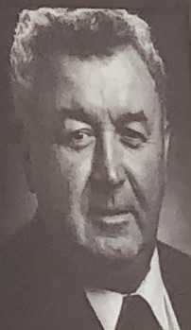
Tribute to Ed Callahan…
Beloved CGIC Board Member and County Commissioner

New Exhibit
Pictured: Tom and Rae Aspitarte proud owners of Martha’s Vineyard of Skamania
1st Wine & Art Openhouse
Friday, June 10th CGICM hosted their first Wine and Art Openhouse in conjunction with the opening of the new art exhibit, “Chasing the Light.” The Interpretive Center was free for all who attended, and offered complimentary light hors-d’oeuvres!

Making the night extra special was local winery “Martha’s Vineyard of Skamania,” named after Tom Aspitarte’s mom. They featured glasses and samples of their incredible Pinot Noir, Pinot Gris, and Chardonnay! CGICM would like to thank Tom and Rae for helping kickoff their quarterly Wine & Art nights… keep on the watch for news about the next evening that will be hosted in September. Hope to see you all there!
The Past Comes Alive at 27th Anniversary
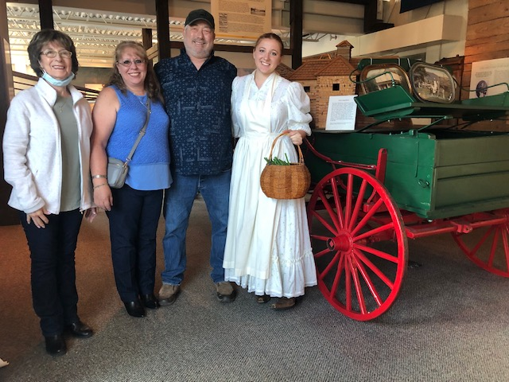
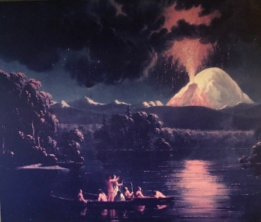
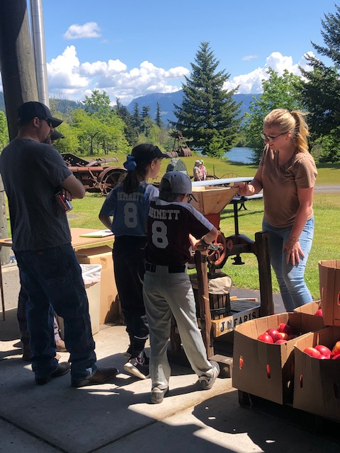
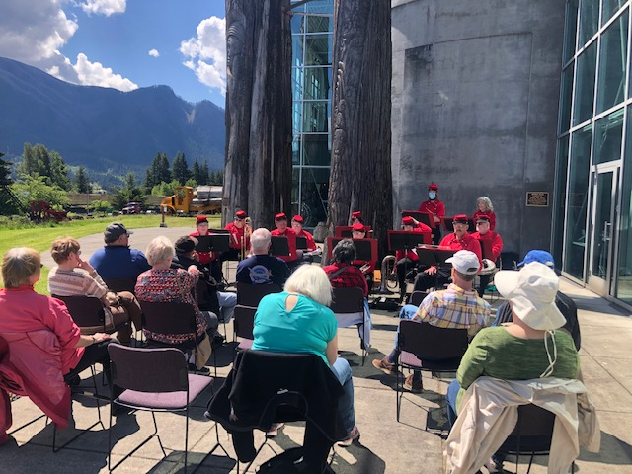
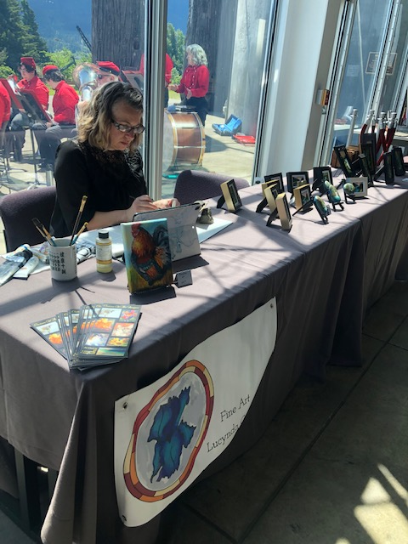
A highlight of the day was the 1967 locally filmed Disney movie “Charlie the Lonesome Cougar,” (featuring the 9-mile long Broughton Lumber Flume, the last working flume in the USA) and FREE popcorn for all.

Local children and visitors from the NW enjoyed a special appearance of local legend “Big Foot,” ancestor to our very own Gifford P. Twiggs. As well as FREE art projects with CASS, and freshly pressed apple cider (top right pic), thanks to an amazing variety of crisp apple’s donated by local business “Mount Adams Fruit Company!”

As visitors enjoyed lunch, history in action, as well as FREE Cake, they could also wander into the Interpretive Center for a upclose visit with local Pioneer “Margaret Iman- the Cinderella of the Gorge.” Margaret’s amazing story was brought to life by volunteer, Brigette Slaughter. Highlighting not just Margaret’s amazing journey across the Oregon Trail as a young girl of 17, but the huge impact that the Iman Family had on Skamania County’s past and future. From the 1st School to opening the Bridge of the Gods! Stop by the Interpretive Center’s Community Gallery today to learn about the Iman Family, one of Stevenson’s 1st settlers!

CGICM would like to thank all the volunteers that made this Anniversary Celebration possible, as well as the amazing videos produced by Duck Up Productions and Get Elevated Media (2nd pic down).
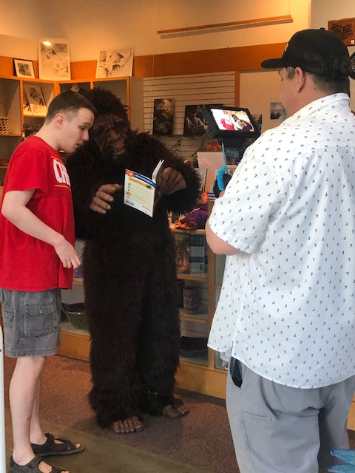
Antique equipment in action, local basket weavers, artists, and a surprise visit by homesteader “Margaret Iman- the Cinderella of the Gorge!”
Photo: Kathleen Iman (mother to Rick), Staci Iman and husband Rick Iman (Great great Grandson To Margaret and Felix Iman), as well as CGICM’s very own Brigette Slaughter.

Saturday, May 21st marked the 27th Anniversary of CGICM and the 62nd Anniversary of the Skamania Historical Society! This was celebrated by a Member and Volunteer Appreciation Day hosted at the Interpretive Center, starting with a flag ceremony- thanks to the Coy-Catlin 137 Legion and local vocalist Naima Muntal who performed the National Anthem.

The day was filled with excellent music and art, featuring the following activities: a concert from the talented 1800’s Brass Band “Whiskey Flats,” incredible oil painter, Lucynda Campbell; 15-year old knife forger Evangel Applegate with “Tiger Blades,” beautiful baskets woven by the “Columbia Basin Basketry Guild,” and an antique machinery display thanks to “Fort Vancouver Antique Equipment Association.”

In 1847, French-Canadian painter Paul Kane ventured down into Washington State in an attempt to paint the active volcano “Mount Saint Helens,” as well as to capture the life of the local natives before all was lost with westward expansion. Paul attempted to hire a group of Multnomah Indians to guide him along the Lewis River to a better view of the majestic mountain. Transportation was declined as the mountain was believed to be the home of a “race hairy giants,” known today as Big Foot! As a result, Kane had to paint the mountain from a safe distance, as seen above in his depiction. Although, it was not erupting lava at the time of his painting, between 1800-1857 the mountain frequently put off steam, ash, and even lava…thus adding to the dramatic painting, a copy of this art is found outside the Degroot Theatre at CGICM!
What does Mount Saint Helens have in Common With CANADA?

BIG FOOT
Q:

A:

Local Trivia >>>
Chasing the Light…
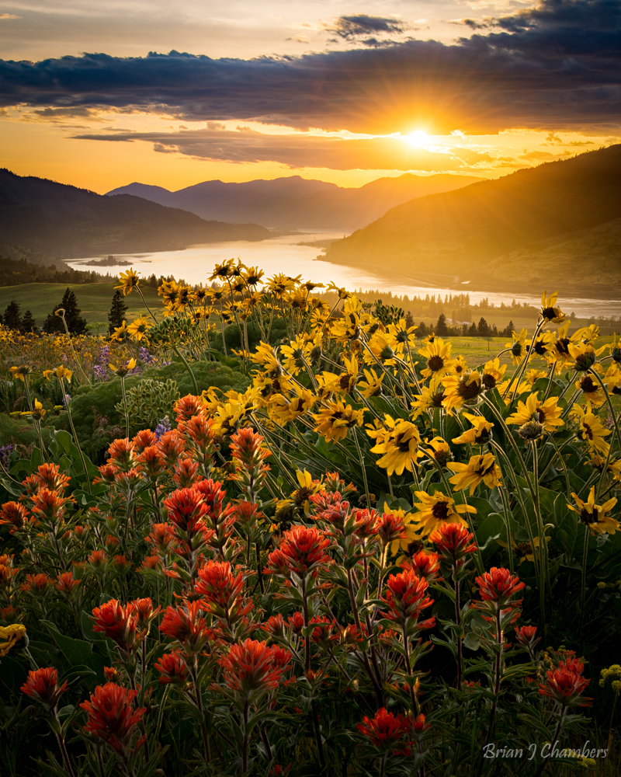

with Brian Chambers…

“There is a big ocean out there, figure out what you are passionate about, and capture what you care about.” – Brian Chambers

From a you boy working a paper route to save for his first camera, Brian quickly learned he had a love for “Chasing the Light” through the eye of his brand new “Pentax ME 35 mm.” Soon Brian would be begging his parents to set up a dark room in their cold, dusty basement so he could process and bring his images to life! As a high school student Brian like so many amateur photographers of his time would dream of becoming the next “Ansel Adams!” Little did he know that one day he would be featured in his own art show at CGICM!

Brian later went to school in Montreal and Massachusetts to become a veterinary, and photography slowly ended up in the hobby category of his life…until he came to the Columbia River Gorge! Brian and is wife ventured out to the Gorge during the landslides of 1996, “even in terrible weather this is a spectacular place,” stated Brian. Caught up in the beauty of the Gorge, as well as the
outdoor activities, Brian and his wife started to look for job openings and within 6 months found themselves relocating from the east coast to the west, even starting a family!

Shortly after coming to The Gorge, digital camera’s hit the shelves, and combined with the incredible natural beauty of his new home, what had been a hobby of photography quickly grew into an obsession and even a career! Columbia Center for the Arts in Hood River, saw his work and encouraged him to display and even sell his images. “My first image sold was bought by a good friend, and my second was purchased from someone in Connecticut. I was convinced my mom bought it, but when I learned it wasn’t, I knew that it really counted,” shared Brian. This was over 12 years ago, today Brian is an award-winning photographer and co-founder of Gallery 301 in Hood River. We are honored to have his work on display at CGICM!

Stop by CGICM during June-August and see first hand the incredible exhibit “Chasing the Light.”

Phone: 509-427-8211
www.columbiagorge.org
www.facebook.com/shewatches
Non-Profit
US Postage
PAID
Permit No. 170
Stevenson, WA
CGICM & SCHS
990 SW Rock Creek Drive
Stevenson, WA 98648

LAST COMPLIMENTARY NEWSLETTER
*Sponsored in part by the City of Stevenson and Skamania County Lodging Taxes

RENEW your membership with the Skamania County Historical Society & Columbia Gorge Interpretive Center Museum
TODAY to continue to receive your copy of “EXPLORATIONS”!!
CALL 509-427-8211 for assistance, WE APPRECIATE YOUR VALUABLE SUPPORT IN PRESERVING OUR PAST!

